CLEARANCE FORM
OJT Name: School:
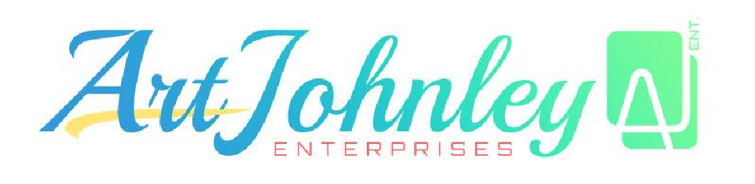

Course: Duration:
DEPARTMENT | CLEARED/UNCLEARED | SIGNATURE
Administrative Department  BSCS  Ivy Taruc | CLEARED
Accounting Department | CLEARED
Sales Department | CLEARED
Logistic Department | CLEARED
HR Department  - Accountability  (Desktop/Mouse/Keyboard/Office Chair)  - Summary of Accomplishments  - Completion of Total Hours | CLEARED
Management Department  - Certificate of Completion  - Approval and Sign Evaluations | CLEARED

Accomplished by: Approved by:

Ivy Taruc
Mark Russel Tagalag
_____________________ _____________________
Chief Executive Officer

Submitted to HR:
Kathlyn Ann Buan
______________________

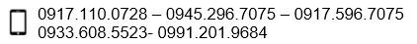

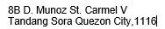
HR/Admin Office

